Plugin Development Guide

Introduction
Savant is unique in the Genome Browser arena in that it was designed to be extensible through a rich plugin framework, which allows developers to provide functionality in addition to what is provided with the standard distribution.

Tutorial: Developing a Savant Plugin
In this tutorial, we describe the steps used to create the Savant Amino plugin using the demo project included in the Savant SDK as a template.

The Amino Plugin:


The Savant Amino plugin was designed to demonstrate just some aspects of the API: in particular, accessing basic information about tracks and rendering it within Savant. It does not cover much of what is offered through the API (for example, creating custom data-sources or visualizations). Most importantly, this tutorial was designed to help you create a foundation for your own plugin project.

Prerequisites:
- JDK
- NetBeans
Note: for this tutorial, it is recommended to download the Netbeans + JDK Bundle from oracle.com.
- Savant SDK

A. Set up the NetBeans Project

1. Set up NetBeans and the JDK
Download NetBeans and the JDK and install them. The links for these are listed above. For simplicity it is recommended to download the bundle, but you can certainly download and install them independently if you wish.

2. Set up the Savant SDK
Download the Savant SDK, listed above, and unzip it. The SDK contains the following components:
- api – documentation of the Savant code
- dev - development materials
- development manual
For this tutorial, we will refer to the dev folder in the SDK as dev/.

3. Open the Demo Project
Open NetBeans. Open the project in dev/savant.demo.

The "Project" and "Files" views should look something like this:
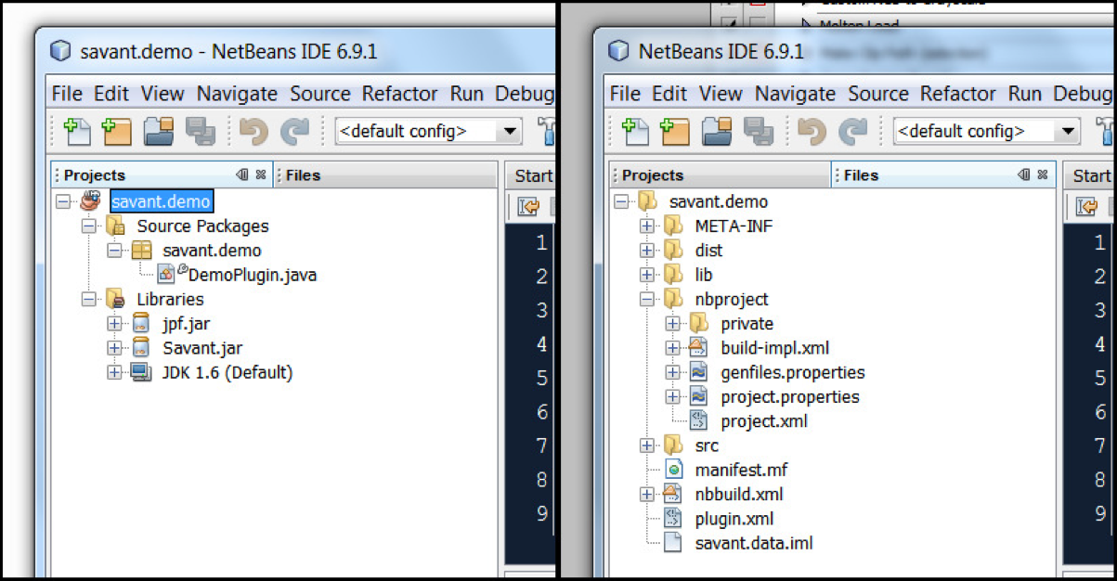

Description of Important Project Files:
- Project View
  - Source Packages: contains implementation of this plugin
    - Main package (savant.demo): contains the main class of the plugin
    - Main class (DemoPlugin.java): the class which implements the Savant Plugin interface
  - Libraries: contains links to external code packages
    - Savant.jar: Savant API, required for accessing Savant functions
- Files View
  - lib/: contains additional libraries used by this plugin
  - nbproject/project.properties : contains NetBeans project properties
  - nbbuild.xml: contains Ant instructions for building the project
  - plugin.xml: contains information about the plugin and how to run it

B. Editing the Demo Project to Your Own Plugin
You will need to know the following properties of your plugin:
- NAME: the name of the plugin.
- VERSION: the version of the plugin. In Savant we use the following scheme for version numbers [major version] . [minor version] . [bug fix / build number].
- PACKAGE: the main package of the plugin (which contains the main class).
- CLASS: the main class of the plugin.
In this example, NAME="Amino Plugin", VERSION="1.0.0", PACKAGE="savant.amino", and CLASS="AminoPlugin".

1. Copy the Demo Project
Right-click the savant.demo project icon (looks like a coffee cup) and choose "Copy...". The copy dialog will be presented. In the Project Name field, enter PACKAGE. Click the "Copy" button.
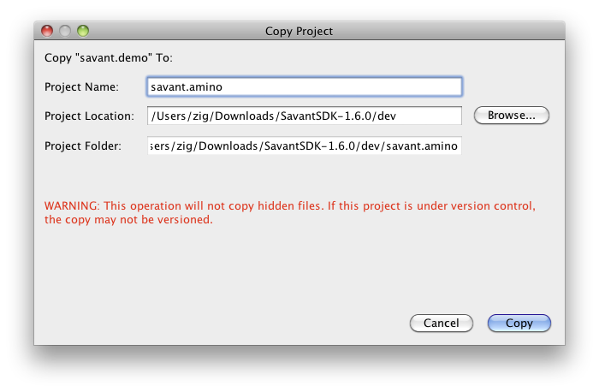
This will create a copy of the demo project which we will now edit to create a new plugin.

2. Rename the main package
Right-click the savant.demo package icon (looks like a cardboard box) and choose "Refactor > Rename...". In the New Name field, enter PACKAGE. Click the "Refactor" button.
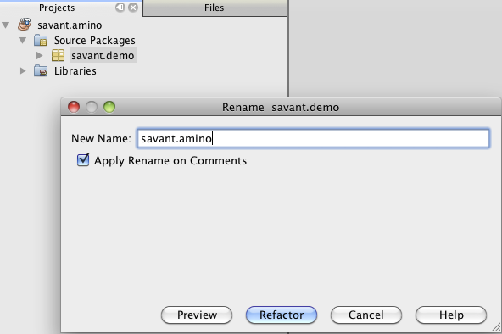

3. Rename the main class
Right-click the DemoPlugin.java icon and choose "Refactor > Rename...". In the New Name field, enter CLASS. Click the "Refactor" button.

4. Change the plugin name
Double-click the CLASS.java file (formerly DemoPlugin.java) to open it in the Editor. Change the getTitle() function to return "NAME".
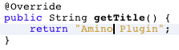

5. Edit the plugin properties
Switch to the "Files" view (the tab beside the "Projects" tab). Expand the new project. Double-click the plugin.xml file to open it in the editor. There are 5 places that need to be edited in this file, denoted in red boxes in the following figure:
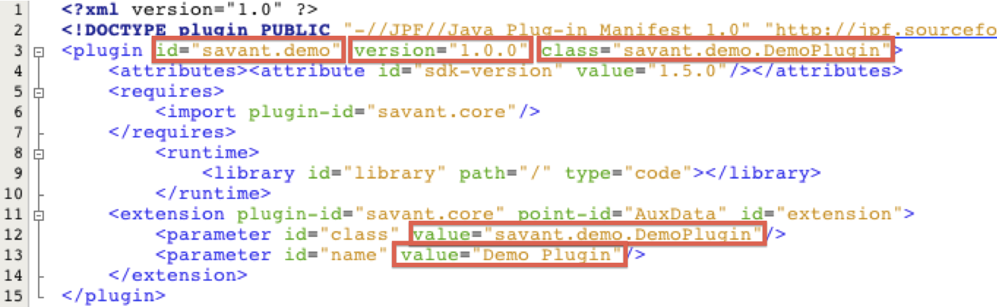
Here is how the file will be changed in the savant.amino example:
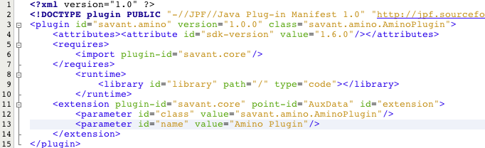

6. Change the project name
Open the nbbuild.xml file in the editor (it's in the same directory as plugin.xml). Change the name attribute of the project to PACKAGE.
At this point, we have created an independent plugin project which can be built and loaded into Savant. It is a good idea to try to do so now. See the section on "Building Plugins" section below.

C. Code Away!
You now have an independent plugin project as a foundation for your own plugin. You have two main tasks, outlined below. If you are following the savant.amino tutorial, you should download the complete savant.amino NetBeans Project to a separate location and copy the Java files in the dev/src directory of that package to the dev/src directory of your NetBeans project (overwriting AminoPlugin.java).
In general, the remaining tasks are:

1. Implementing the init() function
The init() function is called immediately when the plugin is loaded as Savant starts. The init function is responsible for initializing (among other things) the graphical components of the plugin (e.g. buttons, menus, etc.). The graphical "canvas" for plugins is a JPanel provided as an argument to the init() function. For help with JPanel and other Swing components visit <http://download.oracle.com/javase/tutorial/uiswing/>.

2. Implementing the rest of your plugin
Go nuts, you are free to do whatever you like in your plugin!

Suggested guidelines:
- thread long running tasks: Your plugin will run in the main Savant thread unless you tell it to do otherwise. This means that if your plugin does something which takes a long time (e.g. downloads files, performs a long computation, etc.) it will lock up the main thread until it has finished. Please perform such tasks in a separate thread.
- try to stick to what’s in the Savant API packages: The savant.api.adapter and savant.api.utils packages contains classes and methods which the Savant development team considers useful for developers to have. It is possible a developer requires some more functionality that can be found by getting access to a Savant instance. Please notify us of these situations so that we can consciously include such functionality in subsequent versions of the API, otherwise there is a risk that this functionality will be destroyed (since we're not expecting anyone to be using it directly) and your plugin will no longer work.

D. Submit your plugin
We strongly encourage you to submit all your developed Savant plugins to us, so that we can make them directly available to all Savant users. This is both a great way to promote your own work while encouraging more users and developers to join the Savant Community! You can submit your plugins to us through our plugin submission form: http://savantbrowser.com/plugins.php#submit

Plugin Development Tips and Tricks

Building and Testing Plugins
To build your plugin, Right-click the plugin project icon (the coffee cup) and choose "Build". NetBeans should output something like this:
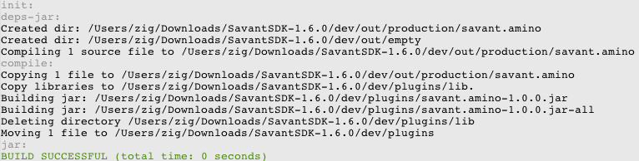
What's important is that it builds successfully. Look in the dev/plugins directory. You should see a .jar file corresponding to your plugin (in the savant.amino example, it is savant.amino-1.0.0.jar).

Now that you've ensured that the plugin was built, you can test out the plugin by running the provided dev/testPlugins.sh script or by running the Savant.jar otherwise (e.g. in Windows, you can just double-click Savant.jar).

Including Other Libraries
You may include additional libraries in your plugin. To do so:
- Place the jar file for the external library in the dev/lib folder.
- In your NetBeans project, right-click "Libraries", then choose "Add JAR/Folder...", then find the jar file and click "Open".
- Open the nbbuild.xml file in the "Files" view in NetBeans, and add a new zipfileset entry under the previous zipfileset entry (near the bottom of the file) for the jar file as follows:
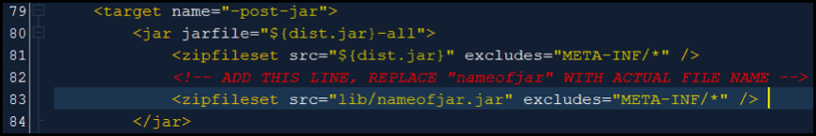

Walkthrough of the savant.amino Plugin
In the samples/savant.amino directory of the SDK download, you will find the completed savant.amino plugin. The code is divided into three files: AminoPlugin.java, AminoAcid.java, and AminoCanvas.java.

AminoPlugin.java
The actual class which implements the Savant plugin. Since this is a GUI plugin, the class it extends is SavantPanelPlugin. The AminoPlugin class has only three methods of note: init(), getTitle(), and getAlpha(). The first two of these methods are required by the SavantPanelPlugin interface.

AminoPlugin.init():
Initialises the plugin’s interface panel. This panel is what the user will see upon selecting the plugin’s tab at the bottom of the Savant window. What the plugin puts in this panel is entirely up to you. For some plugins, like the built-in Data Table plugin, the panel is the essential part of the plugin, for others the panel just provides a way of configuring the plugin’s settings. Since the savant.amino plugin has no real settings to configure, the panel contains only a legend describing the colour scheme used by the plugin.
The init() function also gives the plugin an opportunity to register listeners for Savant events it might be interested in. In this case, the savant.amino plugin listens for TrackEvents and LocationChangedEvents. The former gives the plugin a chance to create an AminoCanvas on which to draw the track’s amino acids; the latter lets the plugin know when the layer canvas needs to be repainted.

AminoPlugin.getTitle():
This required method provides the title for the plugin’s tab in the Savant user interface.

AminoPlugin.getAlpha():
An example of how a plugin can access persistent settings stored in the savant.settings file. As an exercise, you can add a JSlider to the plugin’s panel and use SettingsUtils.setInt() to save the value programmatically. For the time being, you will have to add a line like “savant.amino.AminoPlugin.ALPHA=40” to your ~/.savant/savant.settings file.

AminoAcid.java
This enum defines the constants associate with each amino acid, and sets up a lookup table. The colour scheme is taken from RasMol, which assigns colours according to traditional amino acid properties (e.g. aspartic acid and glutamic acid are acidic and coloured red, while arginine, histidine, and lysine are basic and coloured in bluish shades).

AminoCanvas.java
This class does the work of actually drawing the amino acids. The plugin creates an AminoCanvas when it receives a TrackEvent.Type.ADDED event from Savant, and adds the newly-created canvas to the track’s layer-canvas. Since the AminoCanvas will be drawn on top of the track itself, it calls setOpaque(false) to ensure that it doesn’t completely obscure the track.
The plugin converts between base positions and pixel values using the TrackAdapter’s transformXPos() method. Information about where the starts and ends of coding regions is done using the track’s getDataInRange() method, which returns a list of records. In this case, since the plugin only attaches an AminoCanvas to tracks with data-format INTERVAL_RICH, we can assume that it’s safe to cast these records to RichIntervalRecord.
The actual sequence data is retrieved using the GenomeAdapter class. The rest of the plugin’s logic is devoted to figuring out where the codons start and end.

Walkthrough of the savant.diff Plugin
New in the Savant 1.6.0 SDK is the savant.diff plugin, which is intended to demonstrate how to write a data-source plugin. The data-source plugins most familiar to Savant users are probably the UCSC and SQL plugins, which let Savant display data retrieved from a relational database. For the purposes of the SDK, we will present a much simpler plugin, which calculates the difference between two continuous tracks and displays the result as a third such track.

DiffPlugin.java
The actual class which implements the Savant plugin. Since this is a data-source plugin, it is derived from SavantDataSourcePlugin. The init() and getTitle() methods are required by the plugin interface, but don’t do anything particularly interesting. The actual work is done in the two getDataSource() methods.

DiffPlugin.getDataSource():
The niladic version of getDataSource() is called by Savant when the user chooses the Load Track from Other DataSource option from the File menu. In the case of the Diff plugin, this just presents a dialog to let the user select which two continuous tracks will serve as inputs for the plugin.
More elaborate plugins, such as the UCSC plugin, use this method as an opportunity to log into a database and configure a session. Regardless of the complexity of this configuration process, the results should all be distilled into a single URI which contains sufficient information to save and restore the session. In the case of the Diff plugin this URI consists of the scheme diff:// followed by the URIs for the two input tracks, enclosed in brackets and separated by a semicolon. Together this provides enough information for the plugin to reconstitute the Diff track later.

DiffPlugin.getDataSource(URI):
This version of the getDataSource() method is used when opening a project or using the Recent Tracks menu. It takes the diff:// URI and determines which two tracks to use as inputs. If the Diff plugin were production code, it would include logic to open the input tracks if they were not already loaded. However, since this plugin is just intended as sample code, that extra logic has been omitted for the sake of clarity.

SourceDialog.java
Provides a simple user interface that lets the user select which tracks to use as inputs for the Diff track. The track lists are populated using TrackUtils.getTracks(DataFormat.CONTINUOUS_GENERIC), which provides an array of all loaded continuous tracks, including both ordinary continuous tracks as well as coverage tracks.

DiffDataSource.java
This class provides the plugin’s implementation of the DataSourceAdapter interface. Savant uses parameterised types for its data-sources, so the actual interface implemented is DataSourceAdapter<GenericContinuousRecord>. The GenericContinuousRecord is a simple class which consists of just a position, a reference (i.e. chromosome), and a floating-point value.
The DataSourceAdapter interface requires nine methods to be implemented, but seven of them are trivial. The getDataFormat() and getColumnNames() methods just return constants which are appropriate for continuous tracks. The getURI() method returns the URI which was set by the track’s constructor. For want of anything better to return, the plugin just returns the track’s URI as the value for getName(). The loadDictionary() and lookup() methods are intended for tracks which have named features (e.g. gene tracks), so the methods can just be stubs for a continuous track. Similarly, the Diff plugin has no cleanup to do, so the close() method can also just be a stub.
The getReferenceNames() method is used by Savant to determine which references a track has data for. For a Diff track, this is essentially the intersection of the references for its two inputs. In practice, some tracks store references as “chr1”, “chr2”, etc., while others use “1”, “2”, which means that getReferenceNames() needs to have a bit of extra logic to homogenise these two representations.
The key method of any data-source is getRecords(). Savant gives the plugin a reference, a range, and a resolution, and the data-source is supposed to return a list of data records, ordered by ascending position. In the case of the Diff plugin, this just amounts to calling getRecords() for the two input tracks and calculating the difference between the values at each position. This is complicated somewhat by the fact that there is no guarantee that the input data-sources will return a data-record for every position (particularly at lower resolutions), hence the need for the interpolate() method.

Troubleshooting
If you have any trouble developing a plugin, the Savant Development Team would be happy to help via email to savant [at] cs [dot] toronto [dot] edu.

Copyright © 2011. All rights reserved.

The format of the plugin.xml file is borrowed from the Java Plugin Framework. Much of the file is no longer relevant to Savant’s plugin framework, and can safely be ignored.

